Link Trang Web: <https://mitom2303.000webhostapp.com/langduonglam.html>

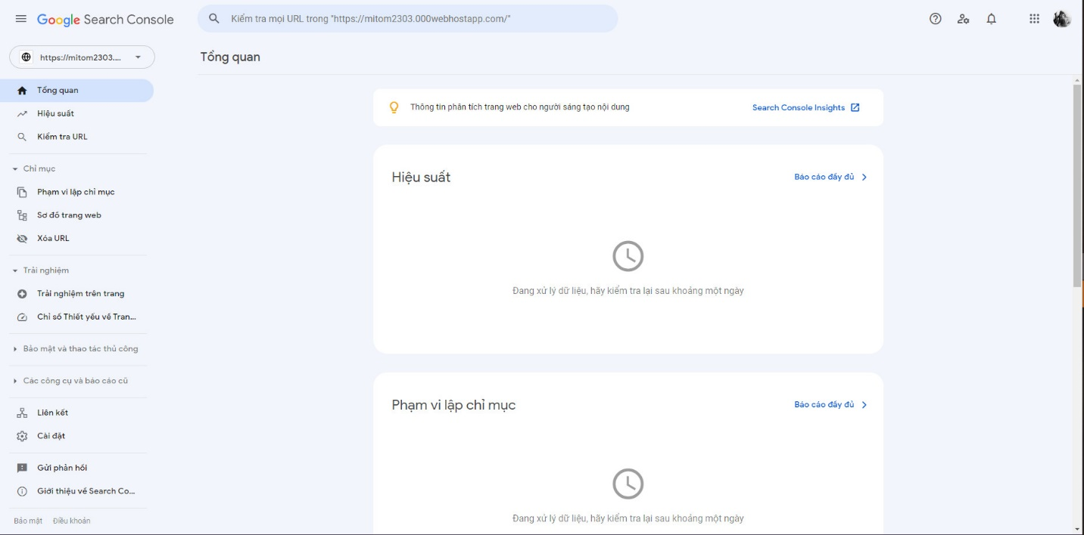

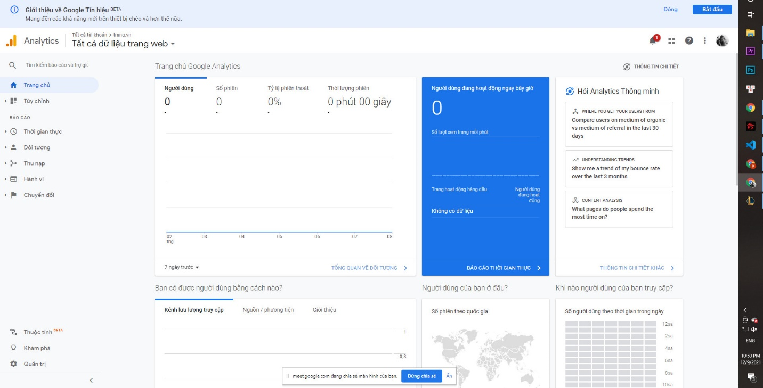

Seo nội dung qua keyword

